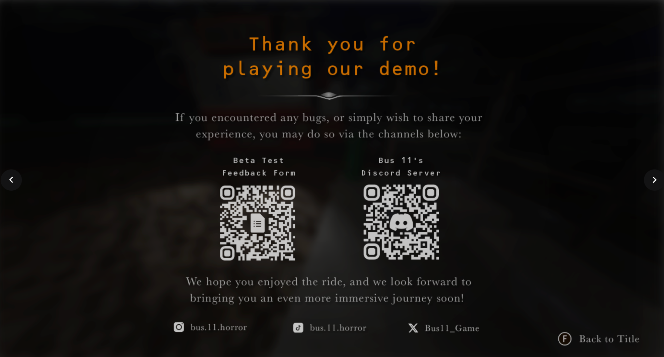

Apply background blur (same as when the pause menu is activated).
Fade in/out repeatedly for ‘F Back to Title’

